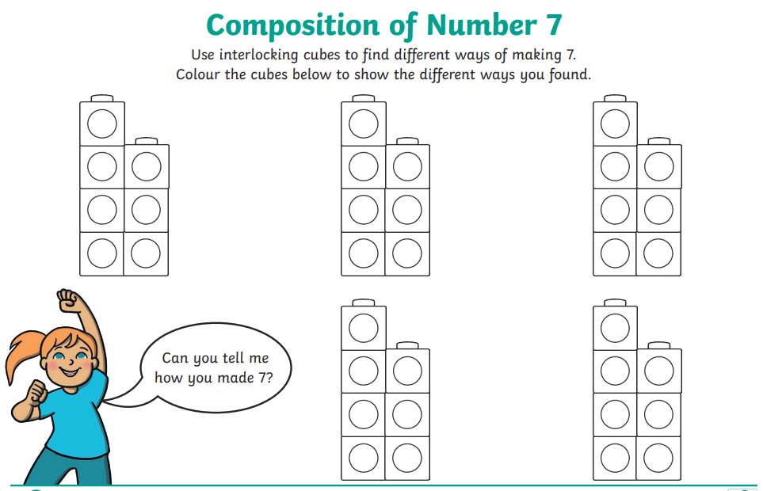

24.01.22

L.C. Can I think about and represent the composition of number 7?