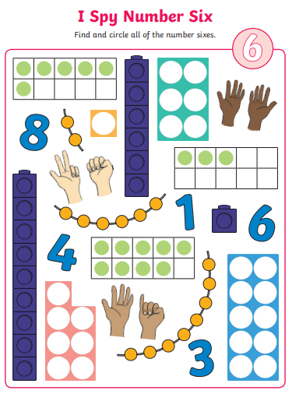

24.01.22

L.C. Can I recognise and circle things that represent the number 6?