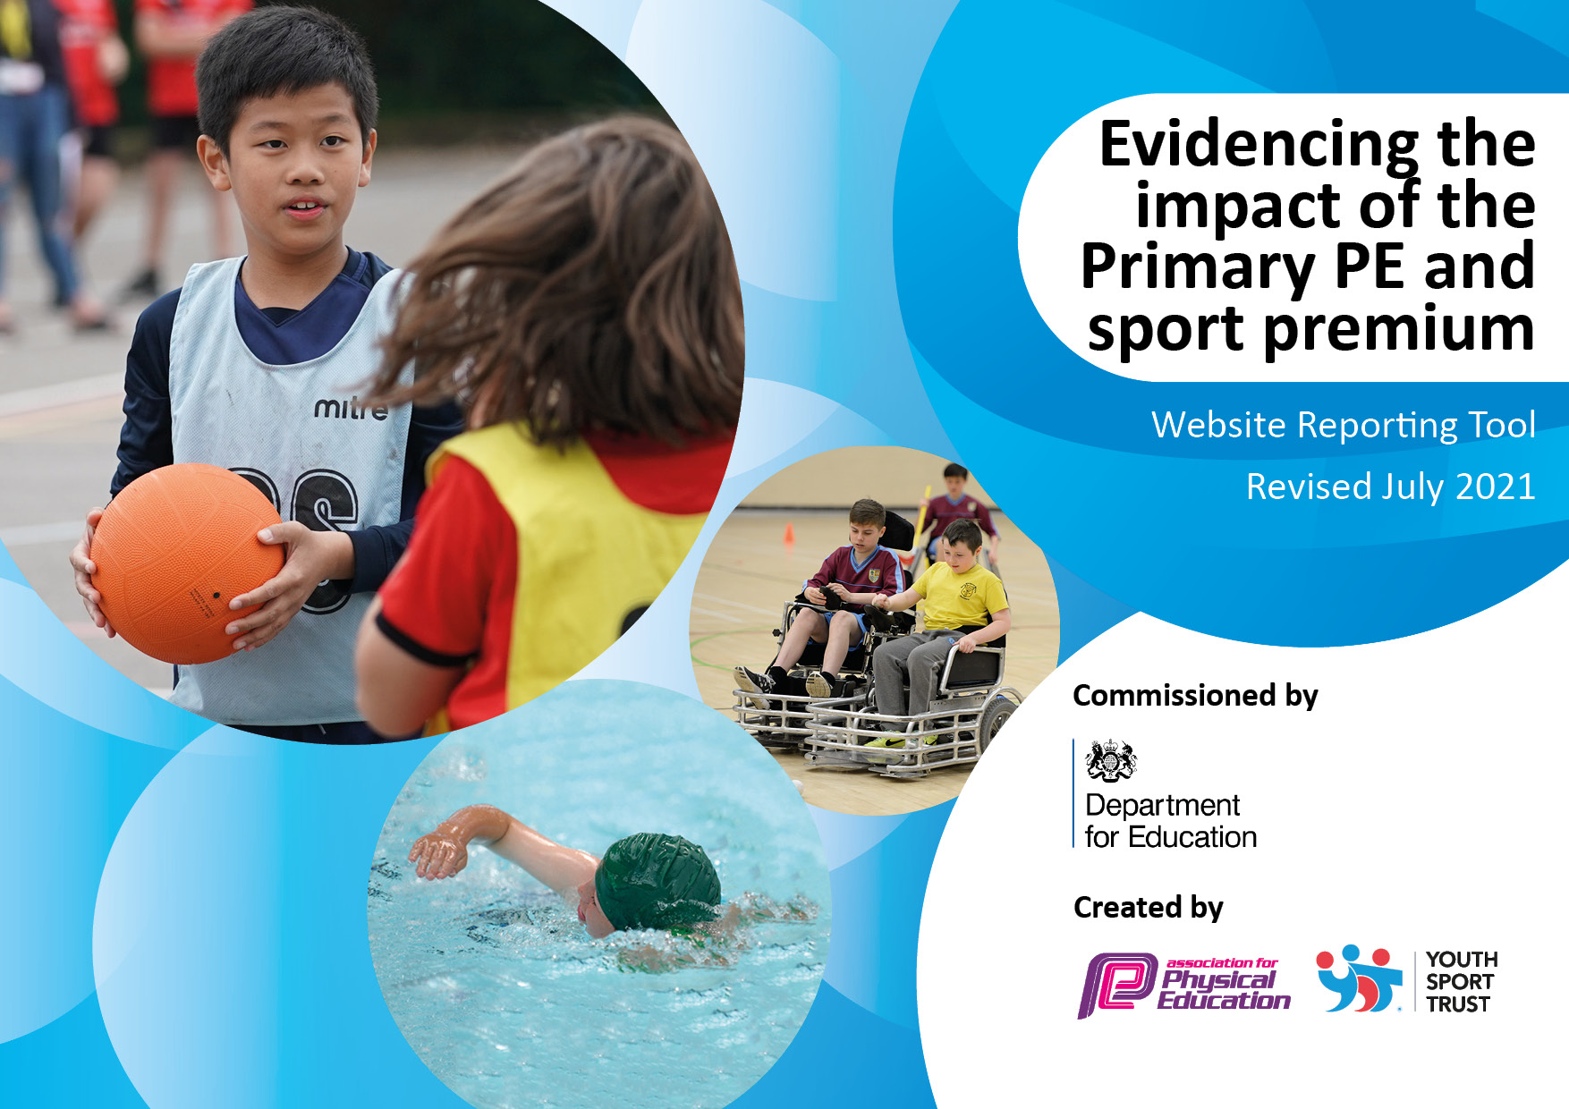
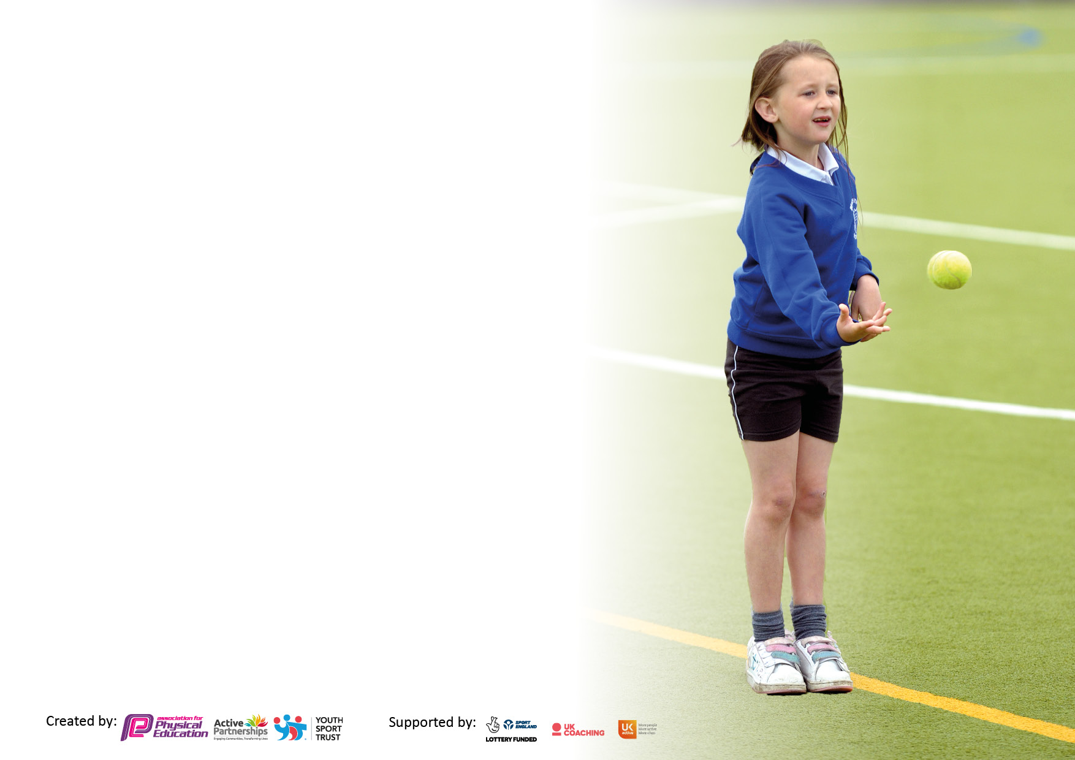

It is important that your grant is used effectively and based on school need. The Education Inspection Framework makes clear there will be a focus on ‘whether leaders and those responsible for governors all understand their respective roles and perform these in a way that enhances the effectiveness of the school’.

Under the Quality of Education Ofsted inspectors consider:
Intent - Curriculum design, coverage and appropriateness
Implementation - Curriculum delivery, Teaching (pedagogy) and Assessment
Impact - Attainment and progress

To assist schools with common transferable language this template has been developed to utilise the same three headings which should make your plans easily transferable between working documents.

Schools must use the funding to make additional and sustainable improvements to the quality of Physical Education, School Sport and Physical Activity (PESSPA) they offer. This means that you should use the Primary PE and sport premium to:

- Develop or add to the PESSPA activities that your school already offer
- Build capacity and capability within the school to ensure that improvements made now will benefit pupils joining the school in future years
- The Primary PE and sport premium should not be used to fund capital spend projects; the school’s budget should fund these.

Pleasevisitgov.ukfortherevisedDfEguidanceincludingthe5keyindicatorsacrosswhichschoolsshoulddemonstrate animprovement.Thisdocumentwillhelpyoutoreviewyourprovisionandtoreportyourspend.DfEencouragesschools to use this template as an effective way of meeting the reporting requirements of the Primary PE and sport premium.

We recommend you start by reflecting on the impact of current provision and reviewing the previous spend.

Schools are required to publish details of how they spend this funding, including any under-spend from 2019/2020, as well as on the impact it has on pupils’ PE and sport participation and attainment. All funding must be spent by 31st July 2022.

We recommend regularly updating the table and publishing it on your website throughout the year. This evidences your ongoing self-evaluation of how you are using the funding to secure maximum, sustainable impact. Final copy must be posted on your website by the end of the academic year and no later than the 31st July 2021. To see an example of how to complete the table please click HERE.

Details with regard to funding
Please complete the table below.

Total amount carried over from 2019/20 | £12,998.08
Total amount allocated for 2020/21 | £17,710.
How much (if any) do you intend to carry over from this total fund into 2021/22? | £14,671.26
Total amount allocated for 2021/22 | £17,700
Total amount of funding for 2021/22. To be spent and reported on by 31st July 2022. | £32,371.26
Swimming Data
Please report on your Swimming Data below.

Meeting national curriculum requirements for swimming and water safety.  N.B. Complete this section to your best ability. For example you might have practised safe self-rescue techniques on dry land which you can then transfer to the pool when school swimming restarts.  Due to exceptional circumstances priority should be given to ensuring that pupils can perform safe self rescue even if they do not fully meet the first two requirements of the NC programme of study | Due to Covid-19 all local swimming lessons were cancelled over the last 2 academic sessions
What percentage of your current Year 6 cohort swim competently, confidently and proficiently over a distance of at least 25 metres?  N.B. Even though your pupils may swim in another year please report on their attainment on leaving primary school at the end of the summer term 2020.  Please see note above | %
What percentage of your current Year 6 cohort use a range of strokes effectively [for example, front crawl, backstroke and breaststroke]?  Please see note above | %
What percentage of your current Year 6 cohort perform safe self-rescue in different water-based situations? | %
Schools can choose to use the Primary PE and sport premium to provide additional provision for swimming but this must be for activity over and above the national curriculum requirements. Have you used it in this way? | Yes/No

Action Plan and Budget Tracking
Capture your intended annual spend against the 5 key indicators. Clarify the success criteria and evidence of impact that you intend to measure to evaluate for pupils today and for the future.

Academic Year: 2020/21 | Total fund allocated: | Date Updated:
Key indicator 1: The engagement of all pupils in regular physical activity – Chief Medical Officers guidelines recommend that primary school pupils undertake at least 30 minutes of physical activity a day in school |  |  |  | Percentage of total allocation:
 |  |  |  | 43%
Intent | Implementation |  | Impact
Your school focus should be clear what you want the pupils to know and be able to do and about  what they need to learn and to  consolidate through practice: | Make sure your actions to achieve are linked to your intentions: | Funding allocated: | Evidence of impact: what do pupils now know and what can they now do? What has changed?: | Sustainability and suggested next steps:
Continued provision of sports clubs to meet the needs and requests of pupils.  Weekly sports clubs available to all pupils in all year groups  Weekly clubs ran by specialist teachers and coaches.  Development of the early years outdoor provision to ensure Early Physical Literacy skills are met.  New equipment purchased to develop the teaching of new sports. Equipment is needed to allow the teaching of new sports to engage the children.  New markings to be added to the school play areas to encourage children to engage in active games. | Promotion of clubs via letter and assemblies  Sport clubs ran by teaching staff to ensure all pupils can engage in sporting activities.  Children are able to engage in sports and dance ran by football coaches  Small and large equipment purchased to ensure that fine and gross motor skills are developed. Large climbing equipment purchased to ensure the whole physical self is developed. Equipment to ensure pupils are physically engaged in their learning in all areas or the Early years curriculum.  New equipment, such as tri-golf and rugby balls to ensure that the offer of types of sports are increased.  Markings on the playground to be added to ensure pupils have a stimulus to use to play active games |  | All clubs well attended and pupils requesting to join after start of the club.  Clubs were popular and pupils engaged in, football, netball, dodgeball and multisports to name a few. Children were asking to join after the term had started.  Children engaged in a sport they love with trained coaches to support the development of older pupils.  Early Years pupils are engaged in physical development. Pupils were able to develop in all areas of physical development. Children developed gross and physical skills.  Pupils were able to develop skills in new sports. Children were asking for the new equipment to be used.  Pupils were more active and played more team games together. | Use of pupil voice to gain an idea of the enjoyment level of clubs. Also to gain a suggested list for the spring and summer terms.  Clubs to reflect pupil choice via Pupil Voice.  Teachers to use the CDP from the sports coaches to continue to develop and expand the range of sports available to pupils.  To ensure that the equipment is planned in to its full potential with the use of continuous provision.  Ensure training in the teaching of the new sports is carried out to ensure the equipment and sports are used effectively.  Encourage children to develop the games used. Pupil voice to see if new equipment (ie bean bags) are needed to develop the physical use of the markings.
Key indicator 2: The profile of PESSPA being raised across the school as a tool for whole school improvement |  |  |  | Percentage of total allocation:
 |  |  |  | 3%
Intent | Implementation |  | Impact
Your school focus should be clear what you want the pupils to know and be able to do and about  what they need to learn and to  consolidate through practice: | Make sure your actions to achieve are linked to your intentions: | Funding allocated: | Evidence of impact: what do pupils now know and what can they now do? What has changed?: | Sustainability and suggested next steps:
Maintain Silver Schools Games Mark. Leadership time and additional PE time.  CPD for all staff provided through sports coaches. Staff able to gain ideas and knowledge of activities, including inclusion of SEND pupils in all areas of PE.  PE equipment updated to ensure appropriate resources are available for staff to deliver good or better lessons in PE. | Release time  Cost of sports coaches and dance teacher.  Staff have an up to date resources list.  Staff have access to all equipment available of lessons. |  | Achieve award and increase pupil engagement in activities/sport.  1 x KS1 staff member and 2 x KS2 staff member have had 6 months (due to C-19 – 12 months was planned) CDP in a range of sports and PE lessons. Knowledge has increased and staff now have a greater understanding of what a good lesson looks like in PE.  Staff have a better understanding of what is available to them. Lessons can be better resourced. | Some activities internally were completed. Due to C-19 most were cancelled. Lead to plan in activities for next academic year under new guidance. Certificate of recognition awarded for the work completed to March 2022.  Staff now to deliver 2 PE lessons weekly, using skills gained in these sessions.  Ensure resources are looked after and maintained.

Key indicator 3: Increased confidence, knowledge and skills of all staff in teaching PE and sport |  |  |  | Percentage of total allocation:
 |  |  |  | 2.5%
Intent | Implementation |  | Impact
Your school focus should be clear | Make sure your actions to | Funding | Evidence of impact: what do | Sustainability and suggested
what you want the pupils to know | achieve are linked to your | allocated: | pupils now know and what | next steps:
and be able to do and about | intentions: |  | can they now do? What has
what they need to learn and to |  |  | changed?:
consolidate through practice:
Planning time for PE lead with teachers.  Delivery of observation lessons for NQT’s.  NQT’ are more confident in what a good lesson looks like in PE and how to set up and develop a lesson.  Introduction on PEDPAS for the teachers to use to help provide appropriately planned and assessed lessons | Release time for PE lead and class teachers.  Release time for PE lead.  PE lessons to be taught by PE lead to NQT class.  Time for staff to plan. Time for PE lead to support staff. |  | Staff feel more confident in delivery of lessons. Lessons planned effectively using a range of tools.  NQT felt more confident in planning and delivering lessons. NQT could see how setting up activities that flow into each other benefit the children’s progress.  Staff have a planning tool to help support them in their planning of lessons. Pupils are engaged in lessons that are appropriate and show progression across year groups. | Monitoring of lessons and additional support in planning a range of lessons.  Targeted support with further members of staff.  Further support In the planning and assessment of PE across the school.
Key indicator 4: Broader experience of a range of sports and activities offered to all pupils |  |  |  | Percentage of total allocation:
Intent | Implementation |  | Impact
Your school focus should be clear | Make sure your actions to | Funding | Evidence of impact: what do | Sustainability and suggested
what you want the pupils to know | achieve are linked to your | allocated: | pupils now know and what | next steps:
and be able to do and about | intentions: |  | can they now do? What has
what they need to learn and to |  |  | changed?:
consolidate through practice:
A range of new sports and activities to be offered through sports coaches and team games  Year 6 to undertake a residential outdoor experience to enhance their understanding of alternative sports. Provide a significant subsidy so all can attend and fund transport to the venue.  Provide boxing club to teach children fitness and self-discipline skills.  Transport to events | Children will be able to compete in a range of new sports. Coaches will tach the skill/rules to new sports to ensure pupils are confident in trying new sports and activities.  Undertake residential. Book appropriate transport to and from the venue.  Use of sports coaches to ensure correct teaching is implemented.  Transport to events to be arranged. Release time for staff. |  | Cancelled due to Covid-19 | Ensure activities are planned in to cover this area and ensure that new guidelines are adhered to.

Key indicator 5: Increased participation in competitive sport |  |  |  | Percentage of total allocation:
 |  |  |  | 0%
Intent | Implementation |  | Impact
Your school focus should be clear | Make sure your actions to | Funding | Evidence of impact: what do | Sustainability and suggested
what you want the pupils to know | achieve are linked to your | allocated: | pupils now know and what | next steps:
and be able to do and about | intentions: |  | can they now do? What has
what they need to learn and to |  |  | changed?:
consolidate through practice:
B teams attending local borough competitions.  Undertake Sports days which allow all children to participate at an appropriate level both in competitive and co-operative ways | Affiliation to the local PE forum Release time for PE lead to attend forum.  Release time to organise participation, complete EVC documentation and PE release time to organise and facilitate sports days Purchase of stickers to celebrate achievements |  | As above  Children enjoyed a sports day that included races they had chosen and all children took part in each race. Children were excited that they all got a sticker for every race they took part in. | As above  Ensure Sports day is in year groups next year for maximum engagement and enjoyment.

Signed off by
Head Teacher: | 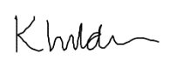
Date: | 01/09/2021
Subject Leader: | L/Eptlett
Date: | 01/09/2021
Governor: | J.Hankey
Date: | 01/09/2021

