STAR PRIMARY ACADEMY -March RETURN - COVID-19
Back to index
HAZARD | RISK GROUP | RISK | CONTROL MEASURES  (Describe the existing workplace precautions and  risk control systems in place) | Residual Risk Rating  HIGH  MED  LOW | Are Existing Controls Adequate?
 |  |  |  |  | Yes | No*
Arriving to academy | Pupils  Staff  Parents  Others | Spread of Infection due to close contact | - Academy to have a one-way system introduced when parents bring pupils to the academy  - Academy to operate entrances and waiting areas outside of academy spaced 1M apart  - Collection and pupil leaving times will be staggered and the process outlined within Access/Egress procedure noted below. The years will arrive and leave at the following times:  Arrival  - Nursery and Year 1 – 8:30  - Reception and Year 2 – 8:35  - Years 3 and 5 – 8:40  - Years 4 and 6 – 8:45  Collection  - Nursery and year 1 - 2:45pm  - Reception and Year - 2 2:50pm  - Year 3 and Year 5 - 2:55pm  - Year 4 and year 6 – 3:00pm  Getting to the academy  - Where possible, we respectfully ask that parents walk their children to the academy.  - If you have to drive, we respectfully ask that you enter Burnaby Street from the junction on Gordon Road and exit Burnaby street onto Hollywall road. Whilst we cannot enforce this, we hope that it will make the road safer and parking easier. Please do not park on the yellow lines.  - Gates open at 8:25am so that you do not have to wait on the street.  - 2 metre distancing signage is still up to remind you that social distancing should be happening. Whilst on site we ask that you remain 2 metres apart. We want to be open long term….  Once in the Gates  - There is a one-way system still in force around the Academy  - There are staggered start and end times so that there is no congestion. (Half hour in total)  - All doors to be between 8:30 and 8:40am so parents will not have to wait. Punctuality with in your time slot is vitally important.  - Teachers will greet you on the outside doors wearing PPE – they will also wear it once inside the classroom.  - Learning Support Assistants will support the children whilst removing coats and bags to hang them safely in the cloakroom area before the next group of children arrive.  - Lunchboxes will be stored in the classroom so they remain with in the class bubble  - Doors closed at the expected time for each class bubble so that punctuality can still be monitored.  - The external academy gates will be locked at 8:50am.  Zones  The zones marking the outside areas are for parents to safely wait  If children wish to use the outdoor equipment, after playing , they will be asked to use hand sanitiser.  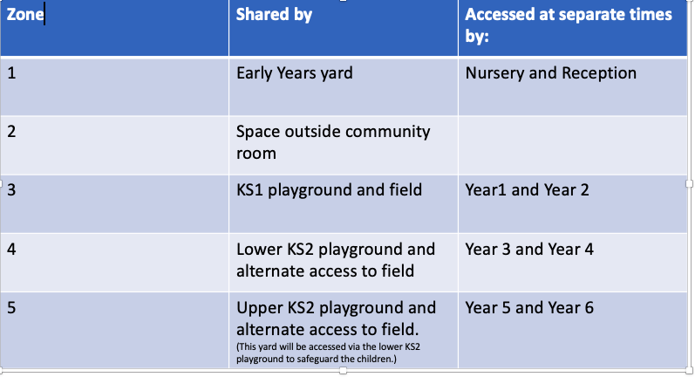  Home time  - Gates will be reopened at 2:45pm – reverse process for collecting coats and dismissing.  - If you do need to wait, please stand in the designated playground zone maintaining a social distance of 2 metres.  - Classroom doors will be open for the duration of the 10 minute time slot.  - Academy gates will be closed at 3:15pm  - Staff member who is outside enforcing the rules should wear a face covering visor, mask and gloves. | HIGH | Yes
Staff receiving child from Parent | Staff | Spread of Infection due to close contact | - Staff members collecting pupils should wear a face, mask, and gloves.  - Staff will direct children to use the hand sanitiser on entry into their classroom (another member of staff supervise pupils) or they will be directed to the sinks within their rooms to wash their hands (member of staff will supervise) | HIGH | Yes
Classroom set up | Staff  Children | Spread of Infection due to close contact | - Teaching staff must keep that 2mtr at all times where possible when teaching.  - Where children may require extra assistance a 2 metre rule must try to be enforced.  - Where 2 metre rule cannot be met Staff members must use PPE available to them ( masks, Gloves, Apron) for face to face teaching  .where side to side teaching is impossible  - The teacher’s desk will be kept 2 metres away from the children’s tables/desks or as far as possible.  - Class bubbles will be no more than 30  - All desks will be forward facing  - Where social distancing cannot be maintained, 1:1 staff working with children to ensure that they are to the side or behind a child, not in front.  - Tissues available around the rooms for pupils to use when coughing or sneezing and they must go into a closed lid bin after one use.  - Maximum number of pupils per room is 30  - Capacity reviews have been completed and plans detailing the arrangements are available to pupils/staff and parents via website  - Soft toys to be removed from Classrooms  - Hand sanitiser to be provided in every room. | HIGH | YES
Classroom Lessons | Staff  Children | Spread of Infection due to close contact | - Teaching staff must keep that safe distance at all times where possible when teaching.  - Where children may require extra assistance the staff member should use the PPE available to them (Visors, masks, Gloves, Apron) if this is needed.  - Hand sanitiser in every classroom and must be used every time a pupil enters the room  - Soft toys to be removed from Classrooms  - All children to have their own bag of resources.  - If children need to move rooms, they will take their resource pack with them (including a dictionary).  - Any books such as dictionaries/ reading books to remain in children’s positions  - Once children are finished with the book, class teachers will quarantine the books for 72 hours between bubbles  - Children to be seated forward facing from year 2 onwards.  - Children are not to sit in any other seating arrangements from Y2-y6 including circles.  - If children are required to sit on the carpet they will sit in row, forward facing, 1m+ apart. | HIGH | YES
Staff receiving LFD Tests on site | Staff | Risk of infection | - All schools should offer regular twice weekly testing to their staff and to carry out LFT at home.  - Testing is not mandatory for staff and they do not need to provide proof of a negative test result to attend school, although participation in testing is strongly encouraged.  - Anyone with a positive result will be required to go home immediately.  - The person is required to isolate for 10 days from the date of the positive LFT (with the test date being day 0). The legal duty to self-isolate is triggered by a positive LFT. It is also necessary for the setting to isolate any close contacts of the case for the 48 hours prior to the LFT test being conducted. This is in-line with the guidance for all other sectors of the community and NHS Test and Trace guidelines
Staff receiving LFD Tests at home | Staff | Risk of infection | - Anyone with a positive result will need to take a confirmatory Polymerase Chain Reaction test,  - If the confirmatory PCR test is positive, the person is required to continue to isolate for the 10 day period. If the confirmatory PCR test is negative, the person can end isolation and return to their normal routine.  - It is necessary for the setting to isolate close contacts of the case for the 48 hours prior to the LFT being conducted. A negative PCR would allow the close contacts to end isolation so we would advise that the wording used allows this is be an option.  - Should the person go on to develop symptoms during the isolation period, the isolation period will restart from the first day symptoms appear.
Testing Staff who have recently returned after a positive result | Staff | False Positives | - If staff have recently (within 90 days) tested positive for COVID-19, they are likely to have developed some immunity.  - These people are exempt from testing by both PCR and LFT within 90 days of a positive test, unless they develop new symptoms.  - However, they may choose to take a LFT after the isolation period. If found positive on LFT, they will be required to self-isolate for 10 days or longer if symptomatic. This should only be done after completion of the required self-isolation period  - A new LFT must not be taken whilst the person is still within a period of isolation. If symptoms (other than cough or a loss of, or change in, your normal sense of taste or smell) persist for longer than 10 days, this isolation period could be longer.  - Further PCR tests, within 90 days of a positive test result, should only be obtained where the person develops a new incidence of symptoms.
Face covering | Pupils  Staff | Risk of spread of infection | - Signs or posters in place on how pupils remove face masks correctly or information given in newsletters prior to start of new term.  - Removal of face masks at the school gate for pupils and staff.  - Staff and pupils to ensure they remove masks correctly and remove without touching the front of the mask (remove by loops on ears).  - If disposable masks these must be disposed of in a closed bin.  - If material re-use masks these should be placed inside a disposable bag and taken home to re-wash before reusing.  - Consider wearing face coverings when in communal areas and moving around the school site.  - Wear face coverings when speaking with parents.  - Wear face coverings when out of your social bubble.  - It is advised a face shield is not worn unless medical reasons prevent from wearing or a valid reason is given (it is safer to use a mask) or for communication reasons  Children in primary school do not need to wear a face covering.
Interventions and breakfast clubs | Staff  children | Spread of infection due to close contact | - Children receiving speech and language therapy will be collected from outside the classroom door.  - Adult will sit to the side of the child for 1-1 session for language  - Teacher will use her plastic screen to place in front of the child when working on speech sounds.  - Resources, table and chairs to be cleaned after every session.  - Children to sanitise hands before entering the room  - Sessions can be run with children in the same year group bubble.  - Children to be forward facing with adult 2 metres away  - Children and staff to sanitise hands before entering the room  - Resources to be cleaned at the end of each session.  - Adult 1m+ away, 2m where possible.  - Children to bring their own resource pack to the session. This includes their own book and dictionary.  - Room to be cleaned by the cleaner before being used by another group.  - Children are walked back to their classroom by an adult.  Outside agencies-  - Adults to have their temperature checked before entering the academy.  - Risk assessment shared before visit (relevant sections)  - Children to sanitise hands before entering the room.  - Parent meetings to be organised via phone or teams.  - Where this is not appropriate 2 metre social distancing must be adhered to. Parents will require a temperature check before entering the building. Room to be cleaned after use.  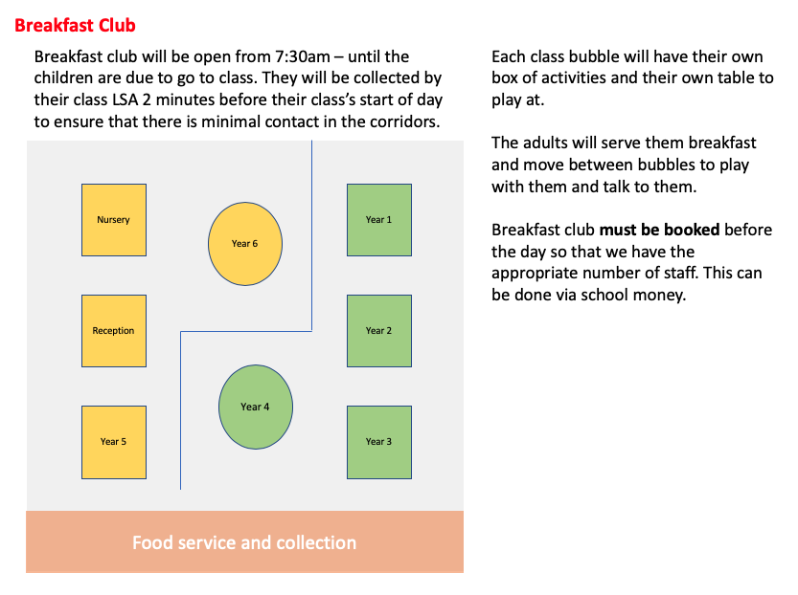 | High | Yes
Children requiring using the toilet in lesson times | Children  Staff | Infection Control | - Hand dryers can now be used and disposable hand paper also used if required  - Inform the child of the importance of washing their hands after using the toilet and on their return to the classroom use the hand sanitiser on entering the classroom.  - Posters placed around site to reinforce this issue  - Toilet breaks to take place at designated times throughout the day and staggered across year groups  - All years to use toilets closest to their classrooms.  - Pupil will use hand sanitiser within classrooms every time they enter.  - Cleaning rota to be laminated and placed in the toilets to monitor the frequency of the cleaning. | MEDIUM | YES
Break times | Children | Spread of Infection due to close contact | - SEE APPENDIX 1 FOR FURTHER DETAILS  - Pupils will remain in their bubble group when outside for breaks/lunch/activities.  - Pupils informed again of the importance of social distancing whilst outside.  - Dedicated area of playground/field to be marked out for each bubble group to use during breaks and same are used each time.  - Teachers to provide activities which can abide by the rules.  - Supervising staff must keep a 2-metre distance from each other at all times. PPE available for staff to use where this is not possible.  - Each class given time for toilets and hand washing- children must be taken by staff in bubble  - Allocated classroom snack time  - Room cleaned whilst in toilets  - Each class bubble allocated area to play outside  - Supervised by staff from own bubble  Zones  The zones marking the outside areas are for children to play in.  If children wish to use the outdoor equipment, after playing , they will be asked to use hand sanitiser. | MEDIUM | YES
Break Times – staffroom | Staff | Spread of Infection due to close contact | - Staff must sit at least 1.5 metres apart from each other whilst eating their lunch.  - Staff must make their own drinks using their own cup  - Single use tea, coffee and milk will be provided  - Staff to bring their own cutlery  - The staffroom can accommodate 4 people at any one time  - Staff are permitted to bring their own lunch and store this in the fridge.  - Fridge will be emptied and cleaned each night.  - Microwave will be available, but this must be cleaned after use.  - No sharing of cutlery or food items.  - Staffroom to be cleaned after use by onsite cleaner. | Medium | Yes
Break Times  Classrooms | Staff  Children | Spread of Infection due to close contact | Member of cleaning staff working through out day to thoroughly clean all touch points  - During breaks they will clean tables and door handles with a disinfectant or disinfectant spray.  - If a child releases bodily fluid in class space, affected area to be cleaned with anti-bacterial spray and wiped with blue paper towels by staff member  - A designated member of Staff to supervise pupils in classroom or outside area. When doing so they will socially distance by 2m.  - Breaks to take place during Lunch when pupil bubble groups are taken outside to designated area and supervised by Midday Supervisor’s/TA  - Staff can also contact the onsite cleaner if the need a space cleaning | MEDIUM | YES
Lunch breaks | Staff  Children | Spread of Infection due to close contact | 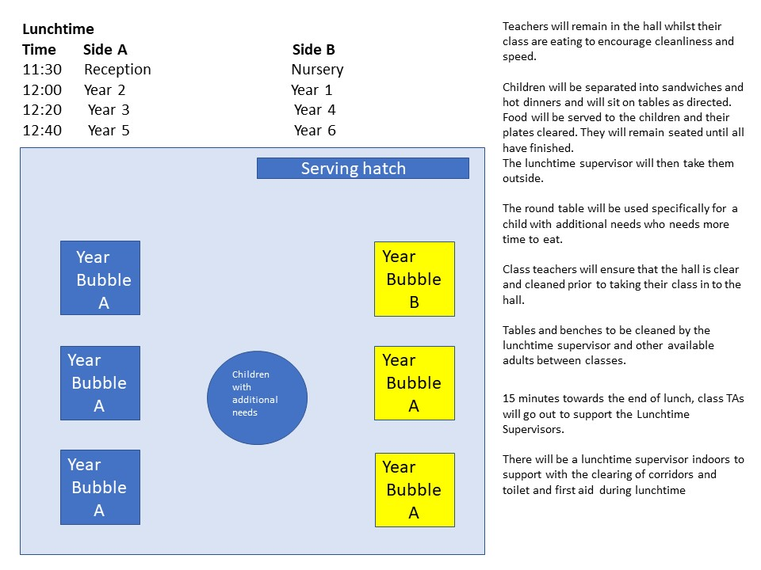  - SEE APPENDIX 1 FOR FURTHER DETAILS  - Room cleaned after eating lunch and rubbish removed  - Children are now permitted to bring packed lunches and these are to be stored in classrooms  - All dietary requirements reviewed before re-opening and details recorded for new pupils receiving onsite cater  - Catering staff to wear PPE if they feel necessary when delivering lunches | MEDIUM | YES
First Aid – minor treatment | Staff  Children | Spread of Infection due to close contact | - Where minor first aid treatment is required First Aiders must ensure they wear gloves and a face covering Mask/Visor/Gloves/Apron and follow ATT procedure when dealing with injuries.  - Where possible (age and maturity of child) ask them to wipe away any blood or hold cold compresses etc.  - Where this is not possible Staff members to wear PPE and dispose of items within closed lid bin immediately after use.  - Ensure records of injury and treatment are recorded and who administered first aid treatment.  - Always wash hands after contact  - PPE used for first aid must be disposed of after use  - Staff to wash hands and sanitise after removal of PPE | HIGH | YES
First Aid – Life threatening | Staff  Children | Spread of Infection due to close contact | - In the event of a serious injury or incident call 999 immediately.  - Wear face covering visor, mark and gloves when in close contact or dealing with bodily fluids  - In the event of CPR being required it is advised only chest compressions are given and use of a defib if available.  - Always wash hands and sanitise after contact | HIGH | YES
First Aid & Medication | Staff  Pupils  Others | First Aid Procedures | - First Aiders must always wear gloves when administering first aid procedures.  - Staff must wear a face covering mask and/or visor if having to deliver close contact first aid and follow ATT procedure for administering first aid (always refer to up to date information from Gov.UK)  - Any dressings used to be double bagged.  - Where any medications are administered try and encourage the pupils to self-administer or staff member must wear a face covering visor, mask, apron and gloves which must be disposed of immediately after use(always refer to up to date information from Gov.UK)  - Staff to wash hands and sanitise after first aid procedures have taken place and PPE removed  - Special Attention must be applied for pupils with specific needs including administering of Insulin and safe storage of this medication.  - Inhalers will be administered based on the guidelines in the child’s H&C plan. Brown inhalers are not to be administered in school  - All medication provided by parents must be signed off at the office | HIGH | YES
Intimate Care | Staff | Lack of Infection Control | - When staff are carrying out any intimate care they must:  - Wear Gloves  - Wear an apron  - Wear a mask  - Wear a visor  - Nappies, wipes etc. must be double bagged and placed into a closed lid bin  - Soiled clothes to be double bagged and given to Parents on collection of child.  - Staff must wash their hands once gloves and masks are removed and dispose of single use PPE  - ATT procedure to be displayed outlining instructions which must be followed.  - Record all intimate care carried out. | HIGH | YES
Children who are upset | Staff | Spread of Infection due to close contact | - Where a child is upset it is advised still trying to maintain a safe distance whilst offering comfort to child.  - Encourage child to use a tissue to wipe eyes/nose etc.  - If contact is required, consider wearing a face covering mask.  - Wash and sanitise hands after contact | MEDIUM | YES
Children with behavioural issues | Staff | Spread of Infection due to close contact | - Where possible allow the child to vent their frustrations  - Where possible allow child to be in a room on their own or outside  - If team teach techniques are required, it is advised face covering mask and or visor, apron and gloves are worn.  - Pupil May need sperate care and attention in another space, area to be designated by academy and PPE used at all times | HIGH | YES
Children leaving at the end of the academy day.  Primary | Staff  Parents  Others | Spread of Infection due to close contact | - Collection and pupil leaving times will be staggered and the process outlined within Access/Egress procedure that is mention above in the “arriving at academy” | HIGH | YES
Parent wishing to talk to staff | Staff | Spread of Infection due to close contact | - Parents will be informed that the majority of conversations with staff will be either over the phone or if this is not possible a meeting will be arranged and social distancing rules observed. PPE will be available for staff to use if social distancing requirements cannot be met  - Parents will be not be allowed onto the academy site and 2 metre spaces clearly marked outside the academy gates and monitored by staff to discourage parents from congregating together. | HIGH | YES
Awareness of policies / procedures / Guidance | Staff  Pupils  Others | Inadequate information | - All staff, returning back to work must ensure they are aware of the current guidelines in regard to safe distancing and washing hands on a regular basis.  - All staff are able to access the following information on-line for up to date information on COCID-19  - Public Health England  - Gov.co.uk  - NHS  - DfE  - Department for Health and Social Care  - The relevant staff receive any necessary training that helps minimise the spread of infection available on ATT LMS and delivered online including:  - Infectious diseases  - COVID19  - First aid at Work  - First Aid Appointed person  - First Aid/Riddor  - Staff are made aware of the academy’s infection control procedures in relation to coronavirus via website, email and staff information packs provided during pre-opening meetings  - Staff to contact the academy as soon as possible if they believe they may have been exposed to coronavirus.  - Parents are made aware of the academy’s infection control procedures in relation to coronavirus via Website, letter, posters or social media – they are informed that they must contact the academy as soon as possible if they believe their child has been exposed to coronavirus.  - Pupils are made aware of the academy’s infection control procedures in relation to coronavirus via academy staff and are informed that they must tell a member of staff if they feel unwell.  - Any unwell pupil will be separated from their group and have their temperature recorded immediately.  - Risk assessments are completed for any high risk staff or staff who are part of the BAME group. | MEDIUM | YES
Poor hygiene practice | Staff  Pupils  Others | Ill Health | - Posters are displayed throughout the academy reminding pupils, staff and visitors to wash their hands, e.g. before entering and leaving the academy.  - Pupils, staff and visitors are encouraged to wash their hands with soap or alcohol-based sanitiser (that contains no less than 60% alcohol) and follow infection control procedures in accordance with the DfE and PHE’s guidance.  - Sufficient amounts of soap and hand sanitiser available in classrooms, clean water and paper towels are supplied in all toilets and kitchen areas.  - Hand sanitiser dispensers have been fixed to the walls of key traffic areas around school. I.e. entrance to playground doors.  - Pupils may be supervised by staff when washing their hands to ensure it is carried out correctly, where necessary using sinks in classrooms  - All hand dryers are allowed to be used..  - Pupils are forbidden from sharing cutlery, cups or food or from bringing these items from home.  - Children can bring in packed lunches from home. See above.  - Air con can be used with windows and doors (Where appropriate) opened to provide natural ventilation  - Cleaners to carry out daily, comprehensive cleaning that follows national guidance and is compliant with the COSHH Policy and the Health and Safety Policy.  - Central ATT Estates team to arrange enhanced cleaning prior to opening which will be undertaken where required – ATT Cleaning provider to provide guidance, risk assessments and cleaning specification prior to re-opening | HIGH | YES
Ill health | Staff  Pupils  Others | Coronavirus  Symptoms | - Staff are informed of the symptoms of possible coronavirus infection, e.g. a cough, difficulty in breathing and high temperature, and are kept up to date with national guidance about the signs, symptoms and transmission of coronavirus.  - Forehead temperature gun in place at academy to take temperature and minimise contact between staff and pupils. Staff and pupils to have temperature checks.  - Any pupil or member of staff who displays signs of being unwell, such as having a cough, fever or difficulty in breathing, and believes they have been exposed to coronavirus, is immediately taken out of the class and placed in an area where they will not come into contact with others and are supervised at all times.  - The relevant member of staff calls for emergency assistance immediately if pupils’ symptoms worsen.  - The parents of unwell pupils are informed as soon as possible of the situation by a relevant member of staff.  - Where contact with a pupil’s parents cannot be made, appropriate procedures are followed in accordance with those outlined in governmental guidance.  - Unwell pupils who are waiting to go home are kept in an area where they can be at least two metres away from others.  - Areas used by unwell staff and pupils who need to go home are appropriately cleaned once vacated, using a disinfectant and care to be taken when cleaning all hard surfaces.  - Room to be taken out of circulation for 72 hours and pupils/staff to self-isolate in confirmed cases of COVID19.  - Fogging treatment to be carried out to affected area in confirmed cases. To be arranged at ATT estates on notification.  - If unwell pupils and staff are waiting to go home, they are instructed to use different toilets to the rest of the academy to minimise the spread of infection.  - Any pupils who display signs of infection are taken home immediately, or as soon as practicable but separated from bubble group, by their parents – the parents are advised to contact NHS 111 immediately or call 999 if the pupil becomes seriously ill or their life is at risk.  - Any members of staff who display signs of infection are sent home immediately and are advised to contact NHS 111 immediately or call 999 if they become seriously ill or their life is at risk.  - Any medication given to ease the unwell individual’s symptoms, e.g. Paracetamol, is administered in accordance with the Administering Medications Policy. | HIGH | YES
Spread of infection | Staff  Pupils  Others | Lack of infection control | - Spillages of bodily fluids, e.g. respiratory and nasal discharges, are cleaned up immediately using anti-bacterial spray and blue paper towels provided within class space in line with guidance, using PPE at all times.  - Cleaning staff on site during opening hours to meet hygiene standards  - Parents are informed not to bring their children to the academy or on the academy premises if they show signs of being unwell and believe they have been exposed to coronavirus.  - Staff and pupils do not return to the academy before the minimum recommended exclusion period (or the ‘self-isolation’ period) has passed, in line with national guidance.  - All pupil trips are to be on hold during this period of re-opening  - Parents notify the academy if their child has an impaired immune system or a medical condition that means they are vulnerable to infections.  - The academy in liaison with individuals’ medical professionals where necessary, reviews the needs of pupils who are vulnerable to infections.  - Any additional provisions for pupils who are vulnerable to infections are put in place by the Principal, in liaison with the pupil’s parents where necessary.  - In extreme cases involving significant risk the decision not to return to academy can be taken in conjunction with the pupils parents. | HIGH | YES
Poor management of infectious diseases | Staff  Pupils  Others | Lack of infection control | - Everyone is instructed to monitor themselves and others and look out for similar symptoms if a pupil or staff member has been sent home with suspected coronavirus.  - Staff are vigilant and report concerns koi about their own, a colleague’s or a pupil’s symptoms to the Principal or SLT as soon as possible.  - The Academy is consistent in its approach to the management of suspected and confirmed cases of coronavirus and follows the ATT procedure.  - The Academy is informed by pupils’ parents when pupils return to academy after having coronavirus – the Academy informs the relevant staff.  - Staff inform the principal when they plan to return to work after having coronavirus.  - Central Estates monitors the cleaning standards of the academy cleaning contractors and additional measures required with regards to managing the spread of coronavirus are being implemented with cleaning arrangements and specification outlined for Academy. | HIGH | YES
Lack of communication | Pupils  Staff  Parents  Others | Infection Control | - The academy staff reports immediately to the Principal about any cases of suspected coronavirus, even if they are unsure.  - Temperature to be taken should any pupil show signs of illness  - The principal contacts the an senior ATT officer( Deputy Estates Director/Estate Director/RED/Senior Operation Officer) and follows the advice given from and discusses if any further action needs to be taken.  - Academy puts into place any actions or precautions advised by the above discussion with ATT officer( Deputy Estates Director/Estate Director/RED/Senior Operation Officer)  - The Academy follows the procedures in the Track and Trace government scheme. Please refer to Track and Trace flow chart in RA 9 for further guidence  - Academy keep staff, pupils and parents adequately updated about any changes to infection control procedures as necessary. | Medium | YES
Cleaning while Academy open | Staff | Infection Control | - Cleaning staff deployed during daytime opening hours 08:30 – 15:30 in addition to regular cleaning hours.  - All touchpoints and hard surfaces to be cleaned on a regular basis throughout the day, this will include  - All door handles  - All tables and chairs used by staff and pupils  - Toilet flushes and regular cleaning of toilets.  - Separate specification to be issued by cleaning contractor  - All classrooms to have spray disinfectant and disposable cloths to clear any spillage during occupation.  - Regular cleaning of surfaces will reduce the risk of spreading the virus.  - All used cloths thrown away to be double bagged and then placed in a secure area/closed lid bin. | MEDIUM | YES
Statutory Tests and Inspections | Staff  Pupils | Health & Safety  Infection Control | - Regional Manager review of Site Health and Safety will be completed prior to re-opening.  - Statutory inspections to continue but with social distancing in place at all times and completed outside of opening hours (prior to 08:30, after 15:45 and weekends)  - In-house inspections will continue to ensure the academy remains as safe as possible.  - Property software regularly updated to show compliance | MEDIUM | YES
Contractors in the academy | Staff  Pupils | Health & Safety  Infection Control | - Contractor visits will be completed outside of opening hours unless in case of emergency required to keep academy open.  - Where contractors are coming into the academy, they must complete academy waiver stating they are free from symptoms and do not have COVID19.  - ALL Contractors must have up to date Risk Assessments and Method Statements and provide copies along with COVID19 safety measures prior to entry to site.  - Control measures regarding the Coronavirus must be included within their RAMs.  - Academy to ensure no pupils or staff are in the area where contractors are working  - Contractors will be designated a toilet they can use whilst on site if out of hours which will then be cleaned or advised not to use on site facilities.  - Contractors will be responsible for removing all rubbish they have created and to clean their area of work prior to leaving. Area will then be thoroughly disinfected  - They must ensure no workers are displaying any signs or symptoms of Coronavirus prior to entering the Academy site and complete academy waiver form.  - If they become aware of a contractor coming down with symptoms within 14 days of being at the academy, they must inform the academy immediately. | MEDIUM | YES
Emergencies | Staff  Pupils | Infection Control | - All staff and pupils’ emergency contact details are up to date, including alternative emergency contact details, where required.  - Pupils’ parents are contacted as soon as practicable in the event of an emergency.  - Staff and pupils’ alternative contacts are contacted where their primary emergency contact cannot be contacted. | HIGH | YES
EYFS  Seating  Snack time  PE | Staff  Pupils | Infection Control | - Where it is possible children will be 1 metre apart.  - Staff will support children from the side or behind.  - During circle time activities children will be sat in a large circle with as much distance as possible between them.  - On PE days Reception children will come in their tracksuit (see uniform policy) to avoid the close contact needed in supporting dressing/undressing by adults. Nursery will keep shoes and socks on, to avoid the close contact needed in supporting putting socks and shoes on/off. | MEDIUM | YES
Outdoor Area | Staff  Pupils | Spread of infection due to sharing resources. | - Outdoor area will be used by Nursery and Reception at different times to stop the spread of infection due to sharing resources. Each class will use their own resources, taken from classrooms.  - Area to be cleaned in between Nursery and Reception using it.
Sand | Pupils  Staff | Spread of infection due to sharing resources. | - Only 4 children to use the sand at any one time.  - Normal sand rules apply, no throwing/flicking sand.  - Wash hands/use hand sanitiser before using sand.  - Wash hands immediately after coming out.  - Sand toys to be washed every evening.  - Sand to be sieved at the end of every week.  - Sand tray to be cleaned and fresh sand put in every 4 weeks. | MEDIUM | YES
Water | Pupils  Staff | Spread of infection due to sharing resources. | - Only 4 children to use the water at any one time.  - Water can be accessed in Nursery and the outdoor area, (not in the Reception classroom).  - Normal water rules apply, no splashing of water.  - Wash hands/use hand sanitiser before using water.  - Wash hands immediately after coming out.  - Water trays to be emptied each evening and washed out.  - Refilled with water each morning. | MEDIUM | YES
Reading Corner | Pupils Staff | Spread of infection due to sharing resources and soft furnishings | - Reading corner will be accessible, no materials or soft furnishings or be used to enhance the area. Wipeable chairs will be available for children to sit on. Children can access the books whilst in school and during reading/story sessions.  - Parents will support children with reading using the Collins e-book parent login. | MEDIUM | YES
Continuous Provision resources | Pupils  Staff | Spread of infection due to sharing resources. | - Children can access resources which can be cleaned or wiped with antibacterial agents.  - Any resources used must be cleaned on a daily basis.  - No materials/ dressing up clothes/dolls with clothes to be used. | MEDIUM | YES
Art and Creative resources | Pupils  Staff | Spread of infection due to sharing resources. | - Scissors, glue sticks or pot of glue with spreader can be accessed by no more than 4 children at any one time.  - Paint can be accessed by no more than 4 children at any one time, using their own brush.  - All resources to be cleaned at the end of the session or before the next group of children,  - Colouring and writing pencils can be shared on tables, cleaned at the end of each day.  - Children to have their own individual labelled pot of playdough? | Medium | Yes
Playground/ Outdoor equipment | Pupils  Staff | Spread of infection due to sharing resources. | - EYFS children will only use Zone 1 and 2 playgrounds for outside play to maximise space, any equipment that is used eg bikes, hoops, balls will be cleaned after use and put away.

