WB: 28.2.21
LC: Can you finish the pattern correctly?

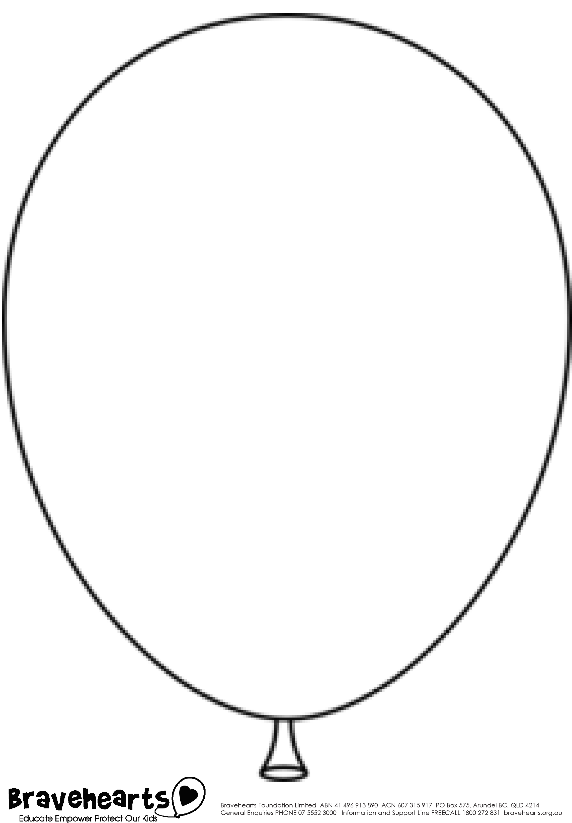

Now can you create your own repeating pattern using 2 colours?

