Wombats

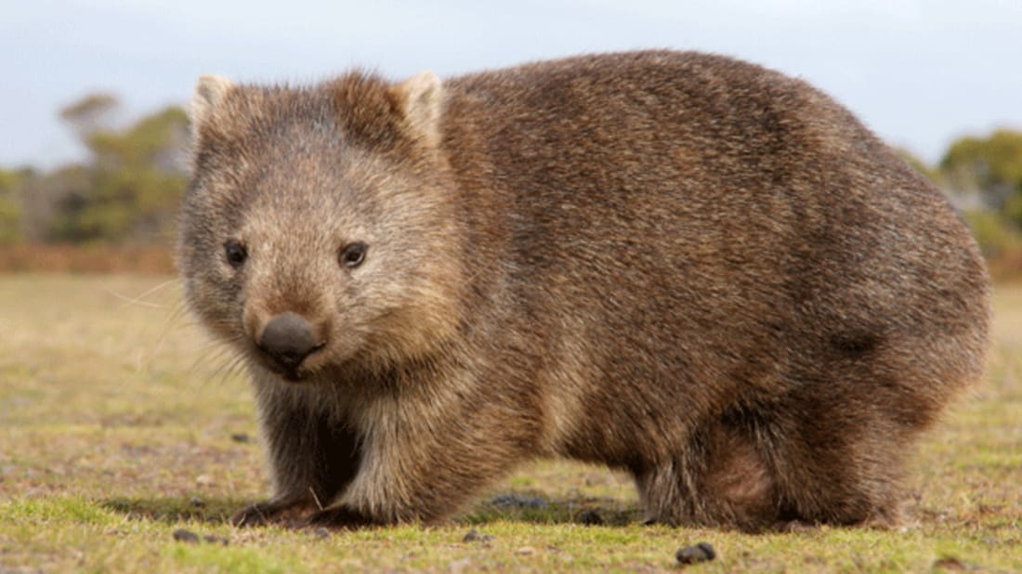

What is a wombat?
Wombats are short-legged, muscular marsupials. A marsupial is an animal that gives birth to live young, which they then carry and feed in a pouch. Wombats can grow to about 1 metre long and can weigh as much as 30kg (which is the same as 200 bananas!).

Where do wombats live?
Wombats live in Australia and some of the small islands surrounding Australia.

What do wombats eat?
Wombats are mainly nocturnal and emerge at night to feed on grasses, herbs, bark and roots. The incisor teeth of a wombat are continually growing, so to keep them in check wombats gnaw on bark and tough vegetation.

Why do wombats burrow?
Wombats have wide, barrel shaped bodies and strong feet with long claws which mean they are made for digging. Wombats excavate extensive systems of tunnels and chambers. Wombats sleep, rest and raise their family in the burrow.

What’s special about a wombat?

- A wombat’s pouch is unusual among marsupials because it faces backwards towards the rump (the area around its bottom). This is so the wombat won’t spray mud into the pouch when it is digging.

- Wombat poo is shaped like a cube. This is because wombats mark their territory using the scent from their poo and having cube shaped pooh stops it from rolling away.

- Wombats have a tough rump. When they feel threatened, a wombat will dive into a tunnel, blocking the entrance with its rump. The sturdy rump prevents predators from being able to remove and attack the wombat.

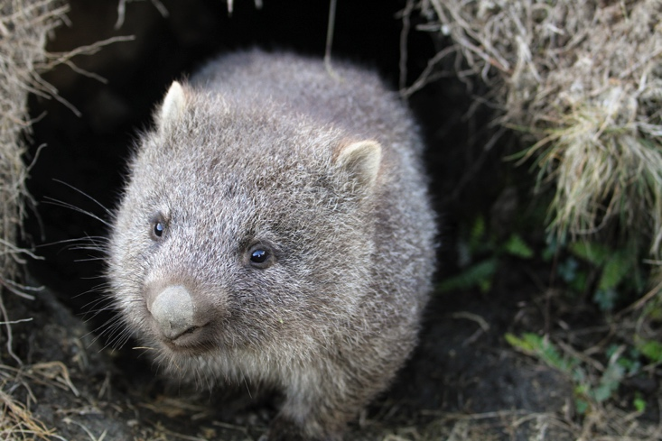

Wombat Questions

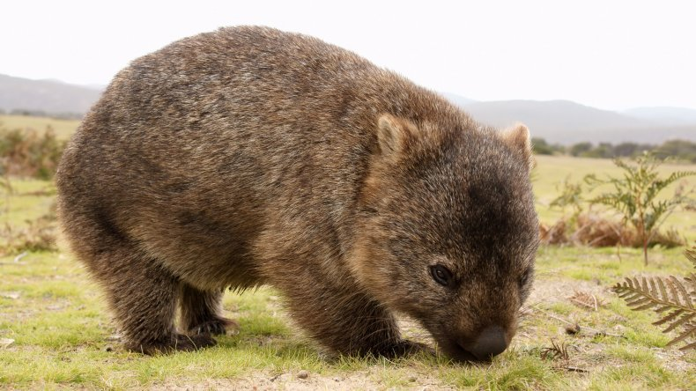

1. Wombats can grow to be 1 metre in length. How many kilograms (kg) can they weigh?

_____________________________________________________________

2. What do wombats do to stop their incisor teeth growing too long?

_____________________________________________________________

3. The text says that ‘Wombats excavate extensive systems of tunnels and chambers’ in the ground. Copy out the word in the sentence which means the same thing as dig.

_____________________________________________________________

4. True or false? ‘Marsupials have pouches that their young grow and feed in.’ Circle either true or false.

5. True or false? ‘Wombats eat frogs, mice and big insects.’ Circle either true or false.

6. In your own words, say why the opening of a wombat’s pouch faces away from its front paws.

____________________________________________________________________________________________________________________________

7. Why is a wombat’s poo cube shaped?
____________________________________________________________________________________________________________________________

8. For what reason do wombats sometimes dive into their burrows and block the entrance with their sturdy rumps?

____________________________________________________________________________________________________________________________

9. Write a caption to go with this picture:





