Label the skeleton using the words below to help you.
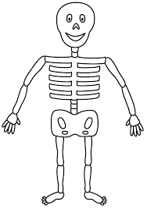
leg | hand | finger | ribs
elbow | toes | foot | skull

