Diary Suggestions

Some things your animal might do wrong:
Your diary could be written by ANY animal you want.  It could be written by an animal you know like a dog or a cat, a squirrel or a garden bird.  Or it could be written by another Australian animal, like a kangaroo, a possum or a platypus, an echidna, a cassowary or a kookaburra.  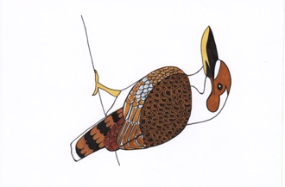  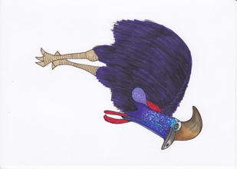  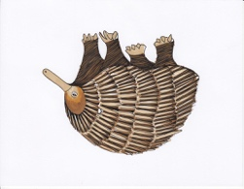  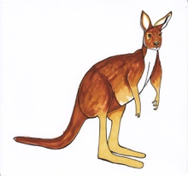  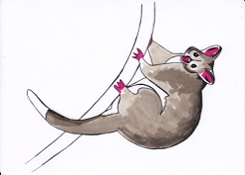  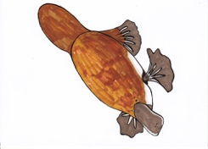 | Break something valuable  Knock something special over  Leave tooth, beak or claw marks on something precious  Get mud or water on something clean  Eat or drink something being kept for a special occasion  Make a lot of noise when it is quiet  Leave fur or hair in the wrong place  Make a horrible smell!

